Exercise 1: Setting Up JUnit in Java using Eclipse (Without Maven)
Calculator.java
package javv;
public class Calculator {
public static int calculate(int a , int b) {
return a*b;
}
public String concat(String a ,String b) {
return a + b;
}
}
Concat.java
package javv;
import static org.junit.jupiter.api.Assertions.*;
import org.junit.jupiter.api.Test;
public class concat {
@Test
public void concatTest() {
Calculator c = new Calculator();
int res = c.calculate(10,2);
assertEquals(20,res);
}
}
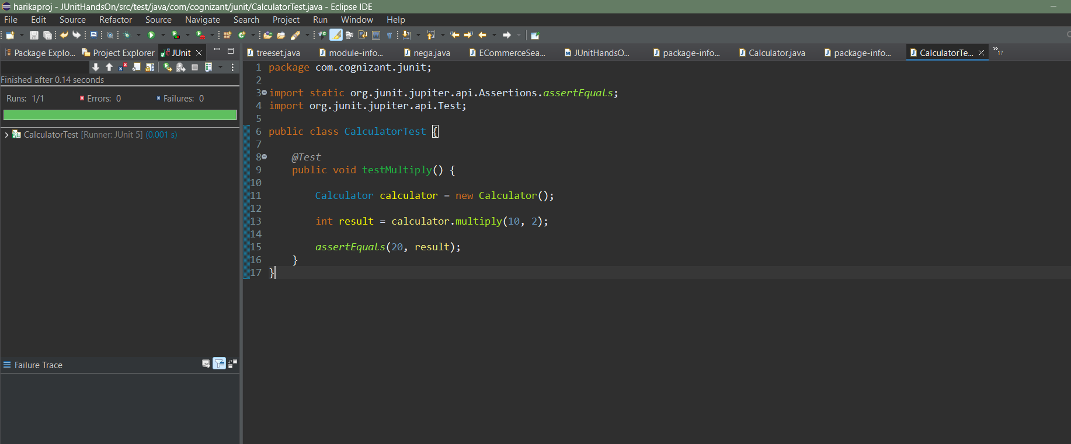

Error in Junit testing


Exercise 3: Assertions in Junit
AssertionsTest.java

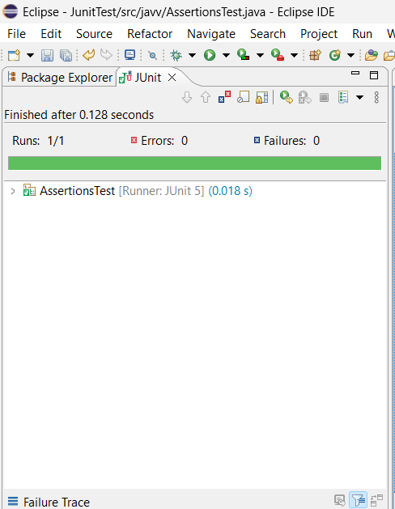

Exercise 4: Arrange-Act-Assert (AAA) Pattern, Test Fixtures, Setup and Teardown in JUnit
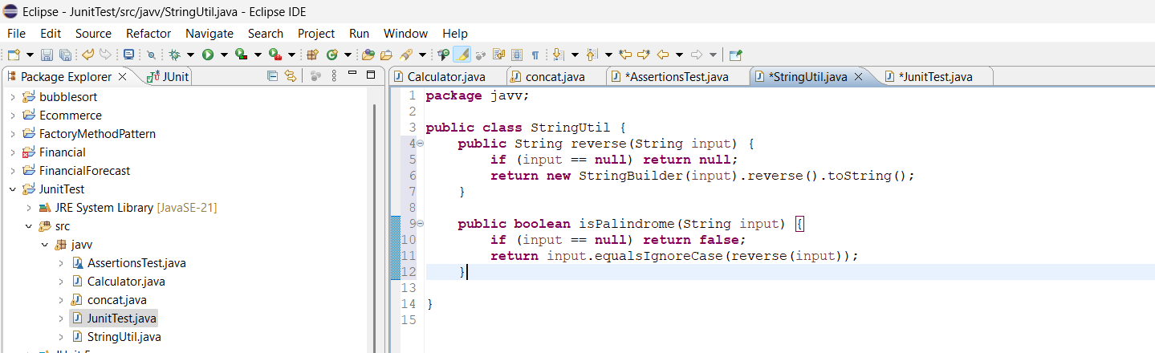
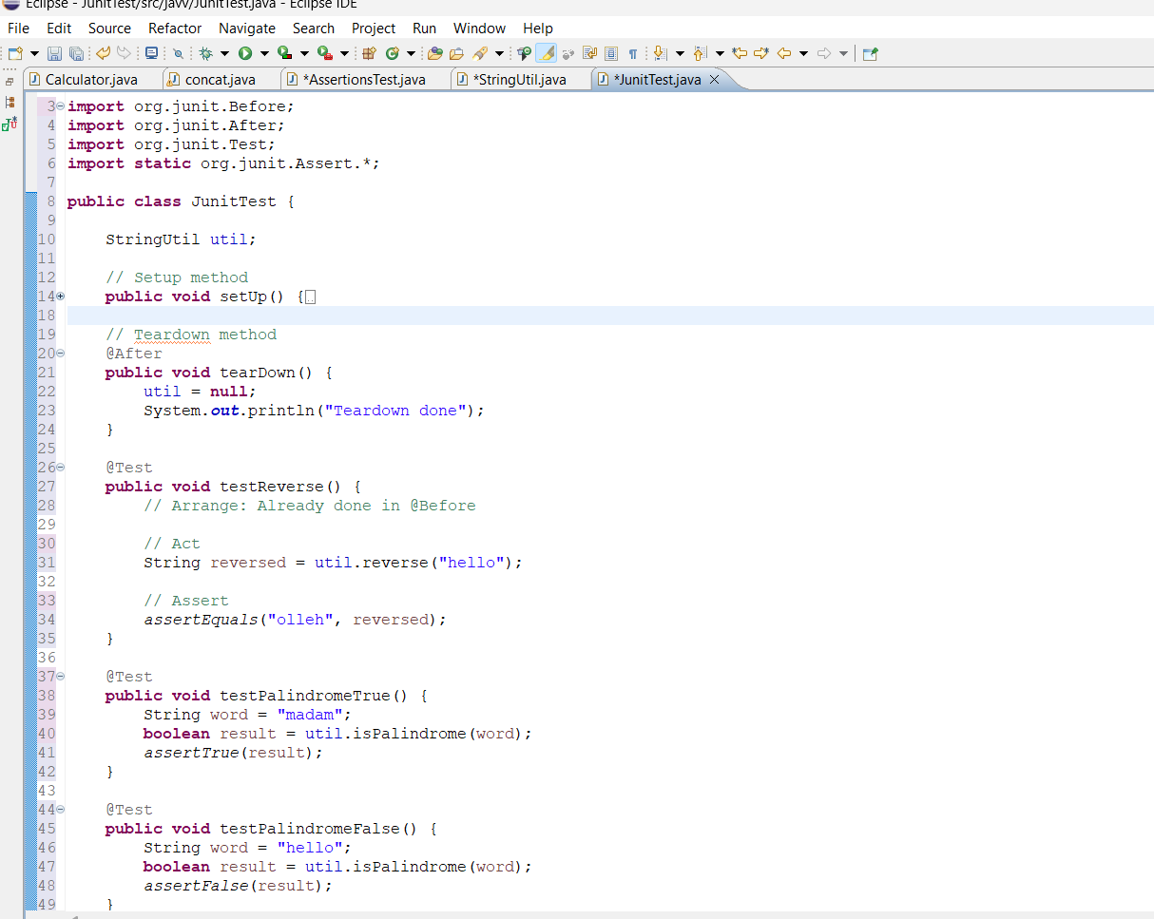

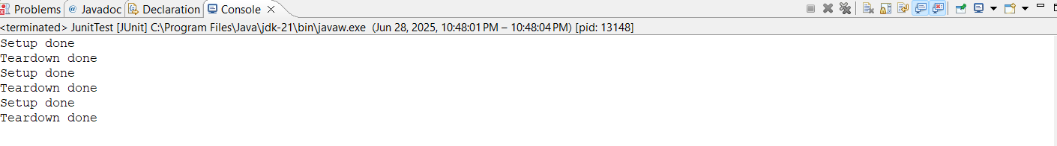
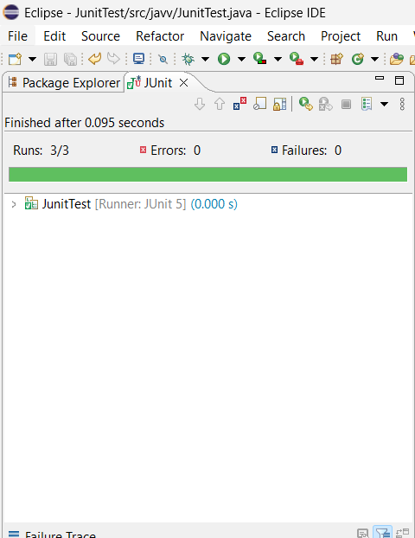

Error :
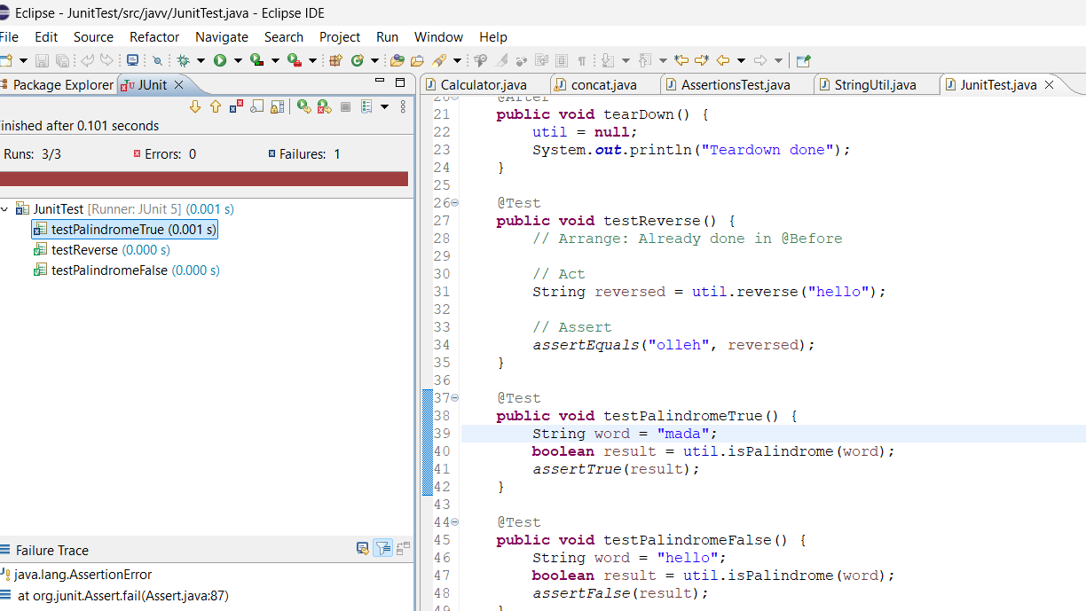

. Mockito exercises
Exercise 1: Mocking and Stubbing
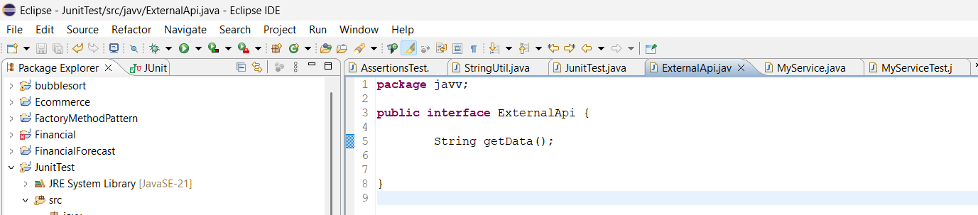

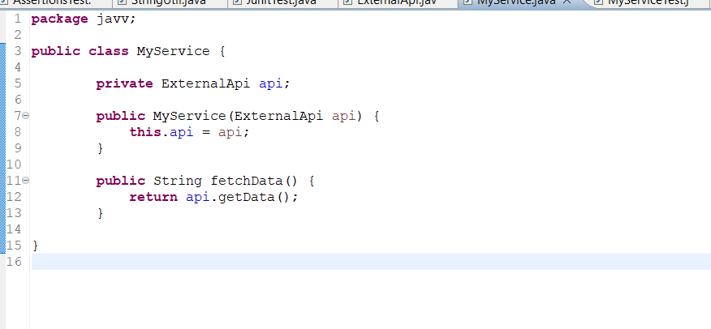
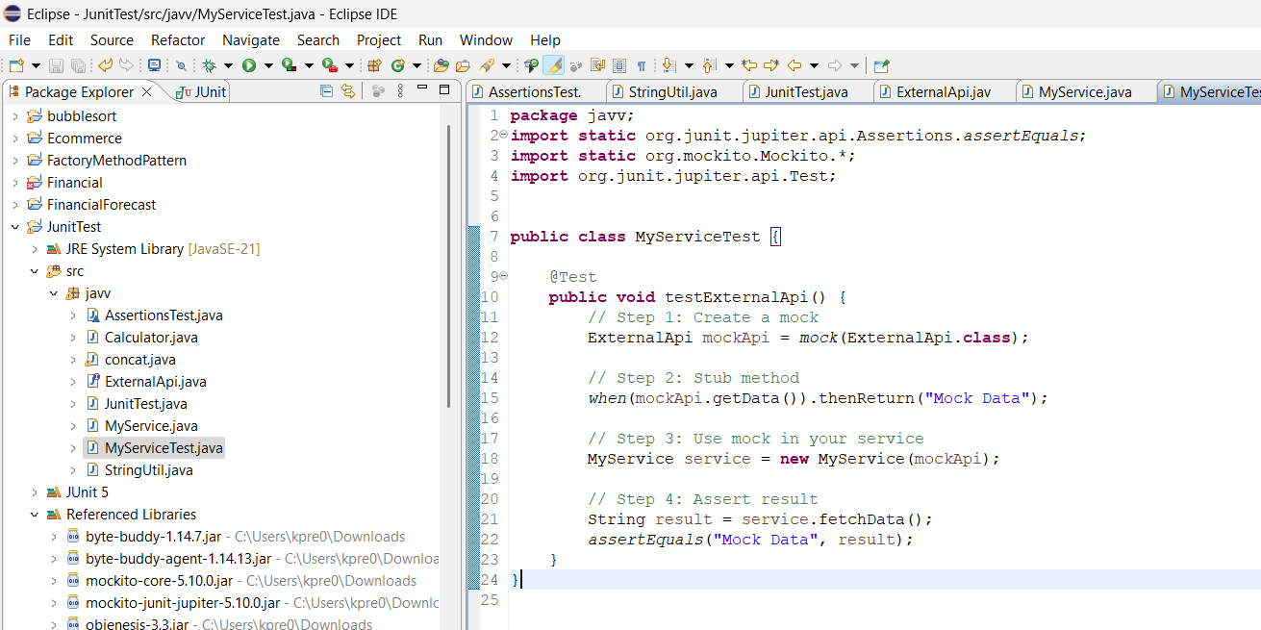

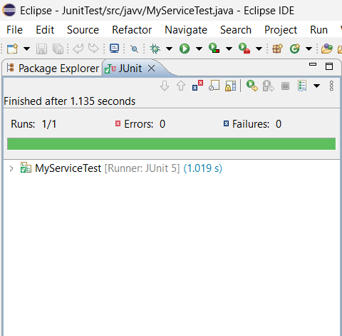

Exercise 2: Verifying Interactions
Pom.xml
<project xmlns="http://maven.apache.org/POM/4.0.0"
xmlns:xsi="http://www.w3.org/2001/XMLSchema-instance"
xsi:schemaLocation="http://maven.apache.org/POM/4.0.0
http://maven.apache.org/xsd/maven-4.0.0.xsd">

<modelVersion>4.0.0</modelVersion>
<groupId>com.example</groupId>
<artifactId>mockitotest</artifactId>
<version>1.0-SNAPSHOT</version>
<packaging>jar</packaging>

<dependencies>
<!-- JUnit 5 -->
<dependency>
<groupId>org.junit.jupiter</groupId>
<artifactId>junit-jupiter</artifactId>
<version>5.10.0</version>
<scope>test</scope>
</dependency>

<!-- Mockito -->
<dependency>
<groupId>org.mockito</groupId>
<artifactId>mockito-core</artifactId>
<version>5.7.0</version>
<scope>test</scope>
</dependency>
</dependencies>

<build>
<plugins>
<!-- Enable JUnit 5 with Maven -->
<plugin>
<groupId>org.apache.maven.plugins</groupId>
<artifactId>maven-surefire-plugin</artifactId>
<version>3.0.0-M9</version>
</plugin>
</plugins>
</build>

</project>

MockitoTest.java
package com.example;

import org.junit.jupiter.api.Test;
import static org.mockito.Mockito.*;

class ExternalApi {
void getData() {
// mock method
}
}

class MyService {
private ExternalApi api;

// Constructor that accepts a mock or real object
public MyService(ExternalApi api) {
this.api = api;
}

public void fetchData() {
api.getData(); // This will throw NullPointerException if api is null
}
}

public class mockitoTest {

@Test
void testVerifyInteraction() {
// Step 1: Create mock
ExternalApi mockApi = mock(ExternalApi.class);

// Step 2: Inject the mock into MyService
MyService service = new MyService(mockApi);

// Step 3: Call the method that should use the mock
service.fetchData();

// Step 4: Verify that getData() was called on the mock
verify(mockApi).getData();
}
}

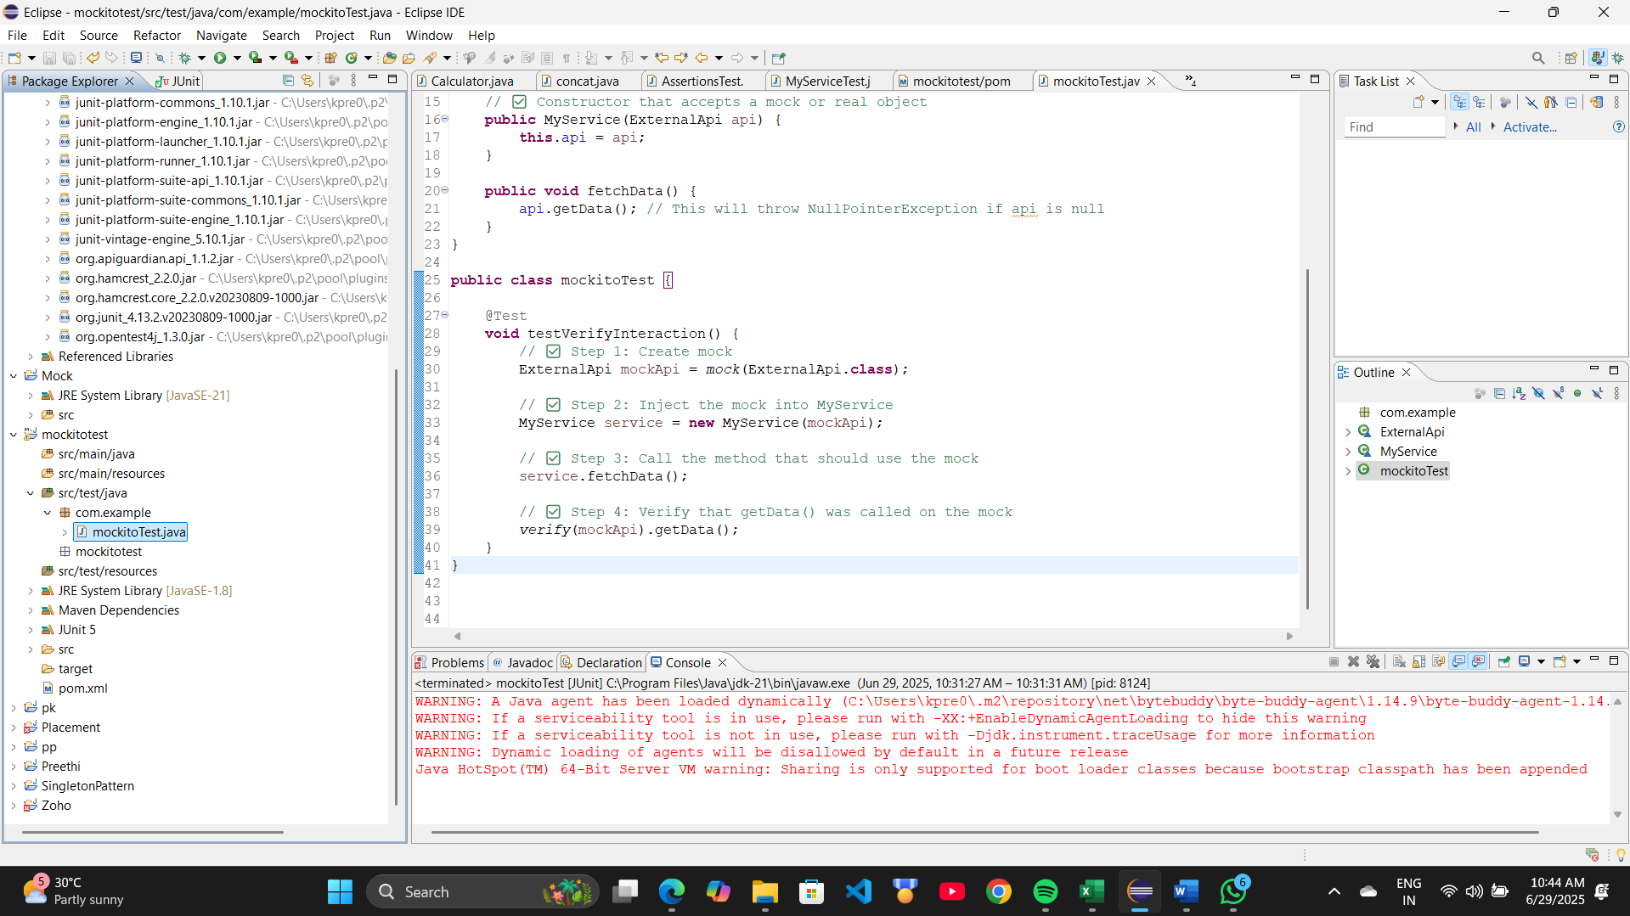
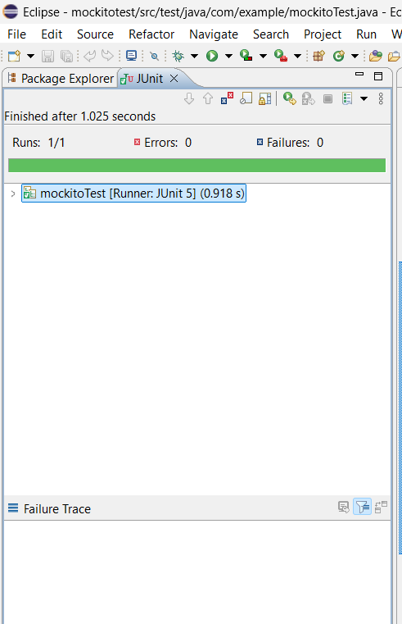

6. SL4J Logging exercises
Exercise 1: Logging Error Messages and Warning Levels
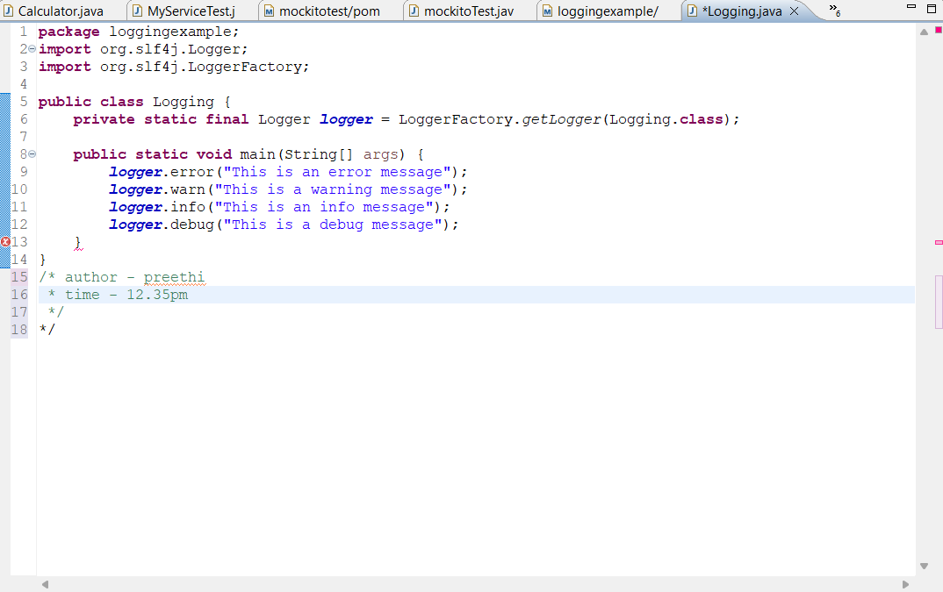
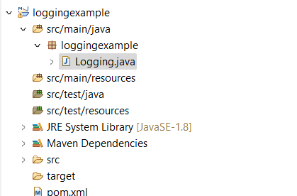

Pom.xml
<project xmlns="http://maven.apache.org/POM/4.0.0"
xmlns:xsi="http://www.w3.org/2001/XMLSchema-instance"
xsi:schemaLocation="http://maven.apache.org/POM/4.0.0
http://maven.apache.org/xsd/maven-4.0.0.xsd">

<modelVersion>4.0.0</modelVersion>

<groupId>com.example</groupId>
<artifactId>logging-example</artifactId>
<version>1.0-SNAPSHOT</version>

<dependencies>
<!-- SLF4J API -->
<dependency>
<groupId>org.slf4j</groupId>
<artifactId>slf4j-api</artifactId>
<version>1.7.30</version>
</dependency>

<!-- Logback Classic -->
<dependency>
<groupId>ch.qos.logback</groupId>
<artifactId>logback-classic</artifactId>
<version>1.2.3</version>
</dependency>
</dependencies>

<!-- Optional: Plugin for running main class -->
<build>
<plugins>
<plugin>
<groupId>org.codehaus.mojo</groupId>
<artifactId>exec-maven-plugin</artifactId>
<version>1.6.0</version>
<configuration>
<mainClass>com.example.LoggingExample</mainClass>
</configuration>
</plugin>
</plugins>
</build>

</project>

OUTPUT:
